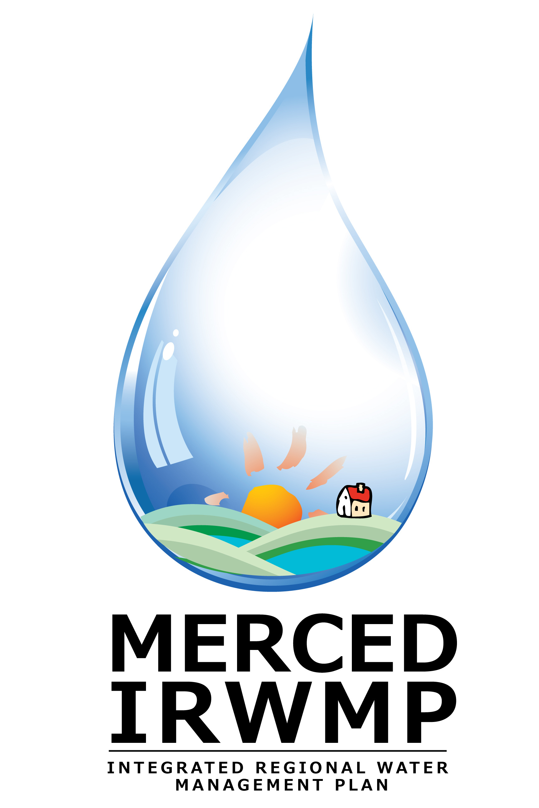
Merced Integrated Regional Water Management Plan

Common Acronyms

Acronym | Meaning
CEQA / NEPA | California Environmental Quality Act / National Environmental Policy Act
DAC | Disadvantaged Community
DFG | Department of Fish and Game
DWR | Department of Water Resources
EJ | Environmental Justice
EPA | Environmental Protection Agency
FEMA | Federal Emergency Management Agency
IRWM | Integrated Regional Water Management
IRWMP | Integrated Regional Water Management Plan
MAGPI | Merced Area Groundwater Pool Interests
MHI | Median Household Income
MID | Merced Irrigation District
RAC | Regional Advisory Committee
RMS | Resource Management Strategy
RWMG | Regional Water Management Group
RWQCB | Regional Water Quality Control Board
SWRCB | State Water Resources Control Board
TM | Technical Memorandum
TOC | Total Organic Carbon
TDS | Total Dissolved Solids
USFWS | US Fish and Wildlife Service
WPMC | Work Plan Management Committee
WTP | Water Treatment Plant
WWTP | Wastewater Treatment Plant

